**NAME -Ananya Malik**

**Sap ID -500110611**

**BATCH =3**

**Assignment 1**

Demonstrate usage of Subversion, Mercurial with commands.

**Title: Demonstration of Subversion (SVN) and Mercurial (HG)**

## ****Introduction****

Version control systems help developers track and manage changes in their codebase. This document demonstrates the usage of **Subversion (SVN)** and **Mercurial (HG)** with essential commands and explanations.

## ****1. Subversion (SVN) Usage****

### ****1.1 Installing SVN****

sudo apt update

sudo apt install subversion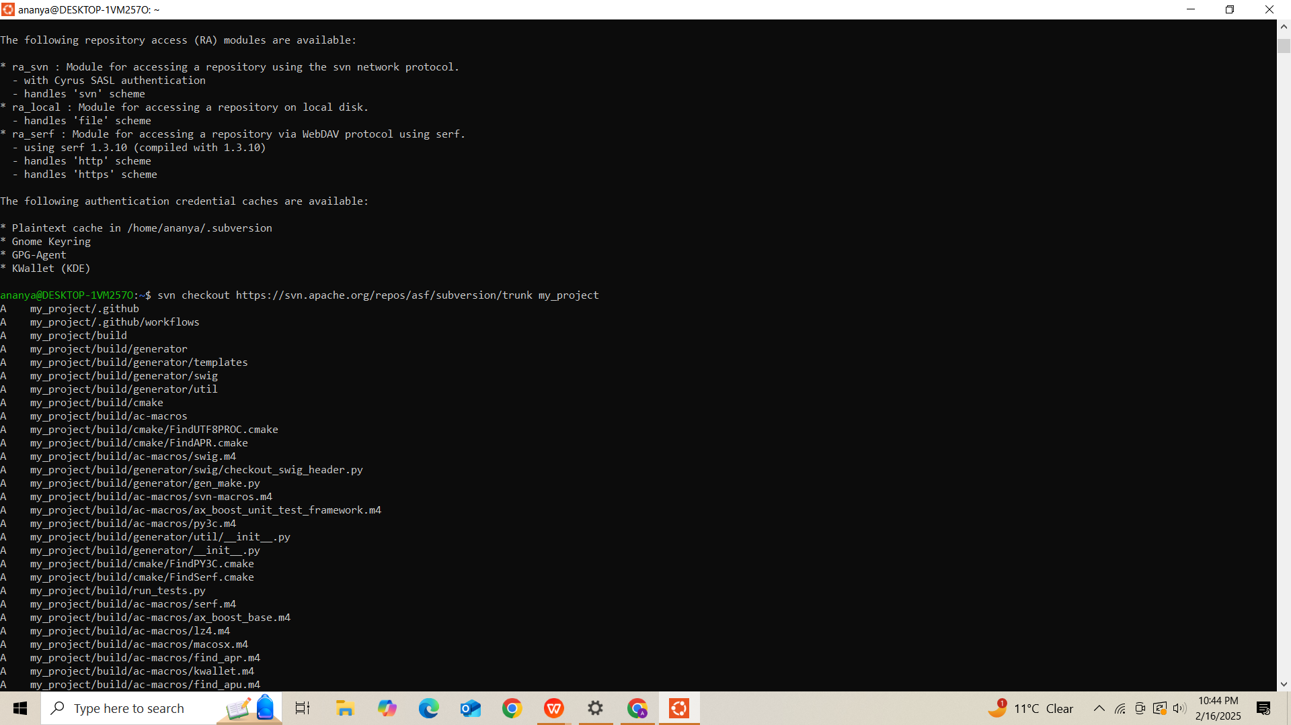

### ****1.2 Checking SVN Version****

svn --version

### ****1.3 Creating an SVN Repository****

svnadmin create my_svn_repo

### ****1.4 Checking Out a Repository****

svn checkout <repo_url> my_project

### ****1.5 Adding a New File****

echo "This is a test file" > newfile.txt

svn add newfile.txt

### ****1.6 Committing Cha**Screenshot (471)Screenshot (472)Screenshot (473)Screenshot (474)**nges****

svn commit -m "Added newfile.txt"

### ****1.7 Checking SVN Status****

svn status

### ****1.8 Viewing SVN Log****

svn log

### ****1.9 Updating SVN Repository****

svn update

### ****1.10 Removing Authentication Credentials****

svn auth --remove --username <your_username>

## ****2. Mercurial (HG) Usage****

### ****2.1 Installing Mercurial****

sudo apt update

sudo apt install mercurial

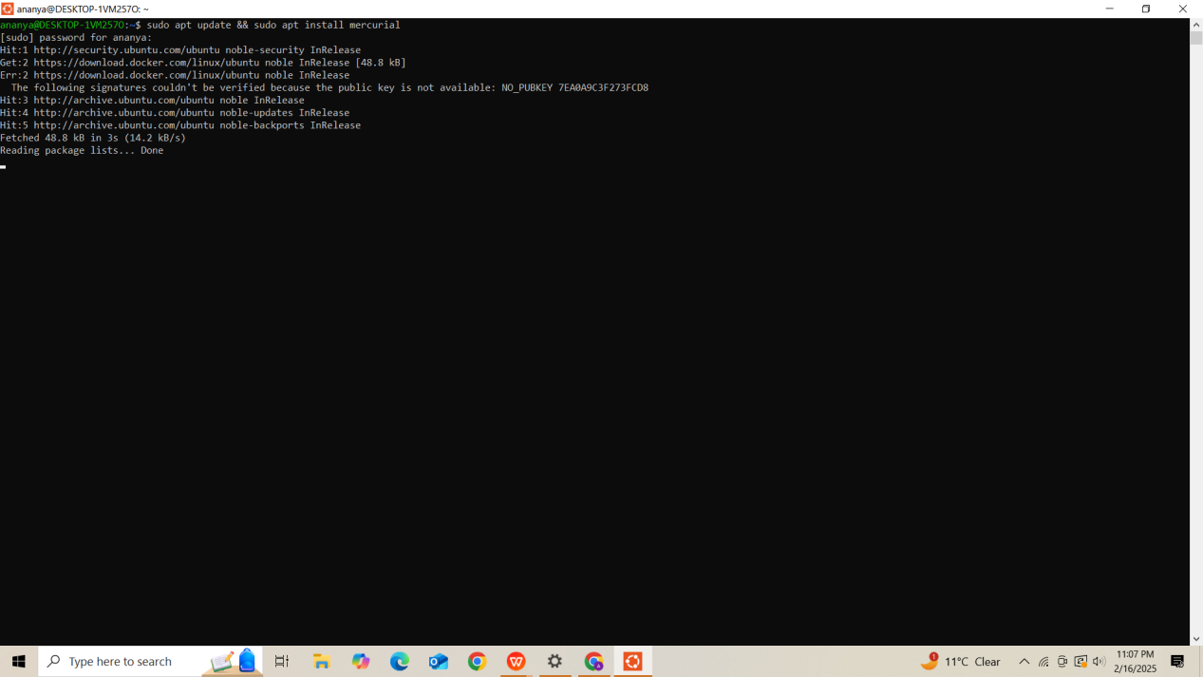

### ****2.2 Checking Mercurial Version****

hg --version

### ****2.3 Creating a Mercurial Repository****

hg init my_hg_project

cd my_hg_project

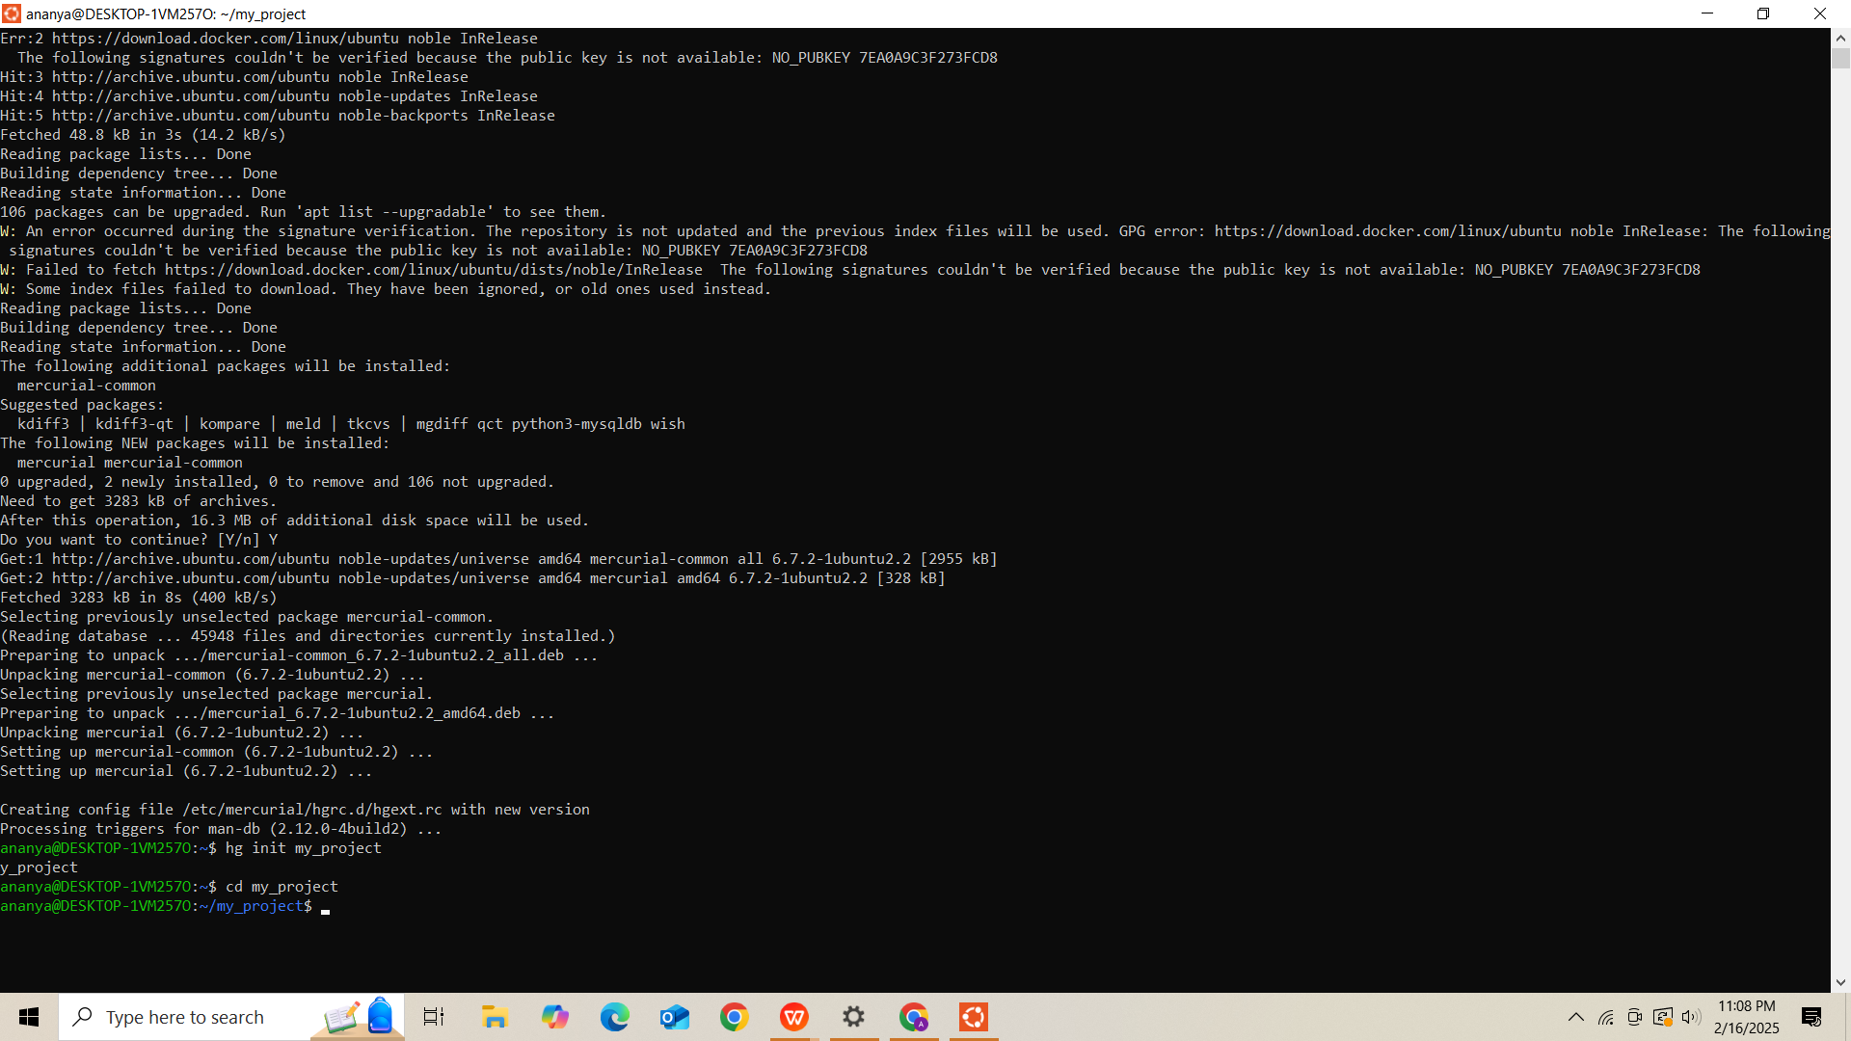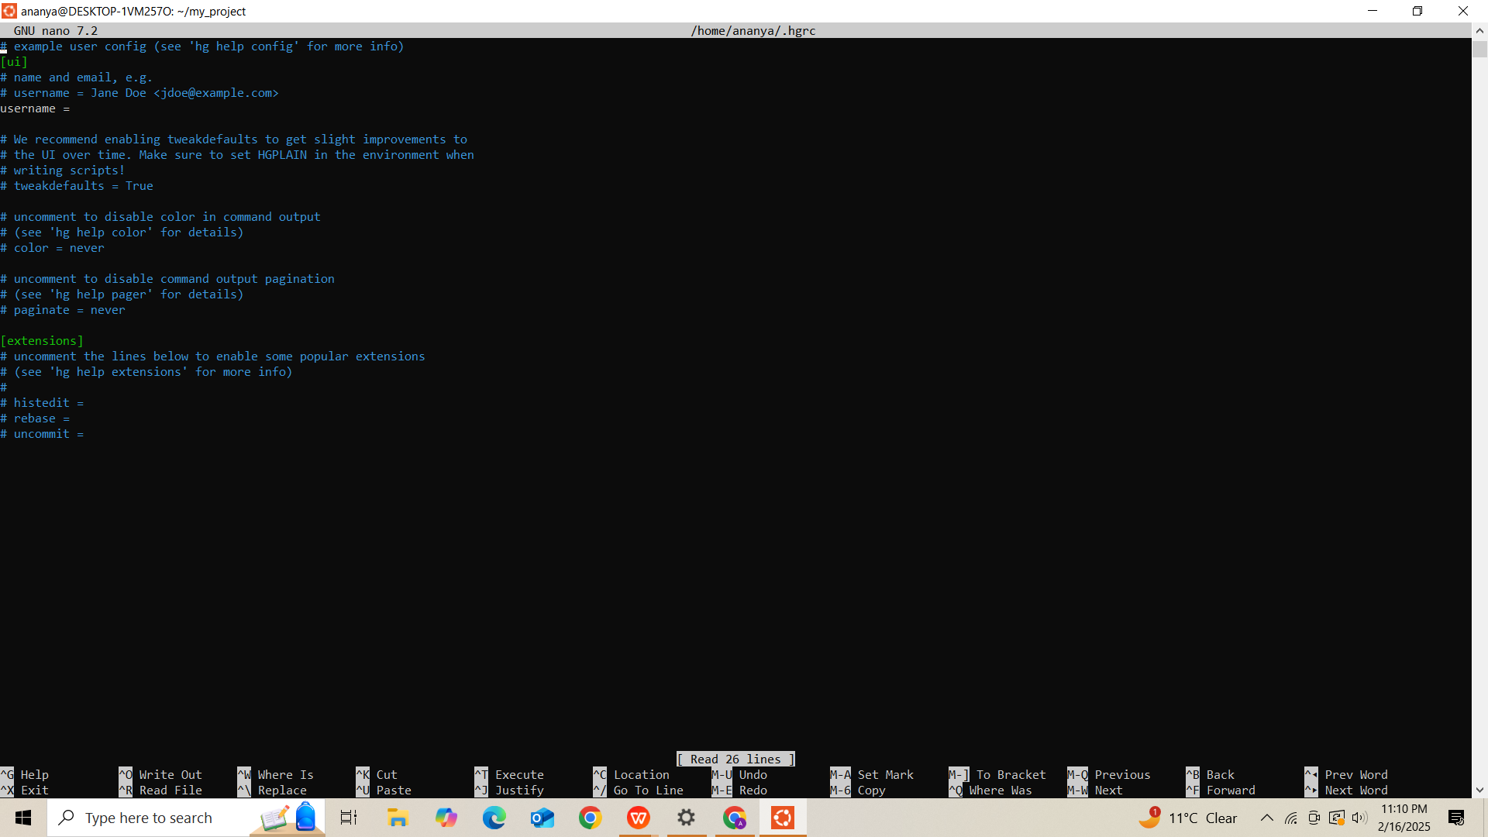

### ****2.4 Configuring Username****

hg config --edit

# Add: ui.username = your_email@example.com

### ****2.5 Adding a New File****

echo "This is a Mercurial test file" > test.txt

hg add test.txt

### ****2.6 Committin**Screenshot (483)Screenshot (484)**g Changes****

hg commit -m "Added test.txt"

### ****2.7 Checking Mercurial Status****

hg status

### ****2.8 Viewing Mercurial Log****

hg log

### ****2.9 Pushing Changes to a Remote Repository****

hg push <remote_repo_url>

## ****3. Hosting the Report on GitHub****

Then we will host it on github